**Payment gatway method using stripe:-**

1. Go to google search (<https://github.com/stripe/stripe-php> download file
2. Unzipe file
3. -> create file in htdocs folder

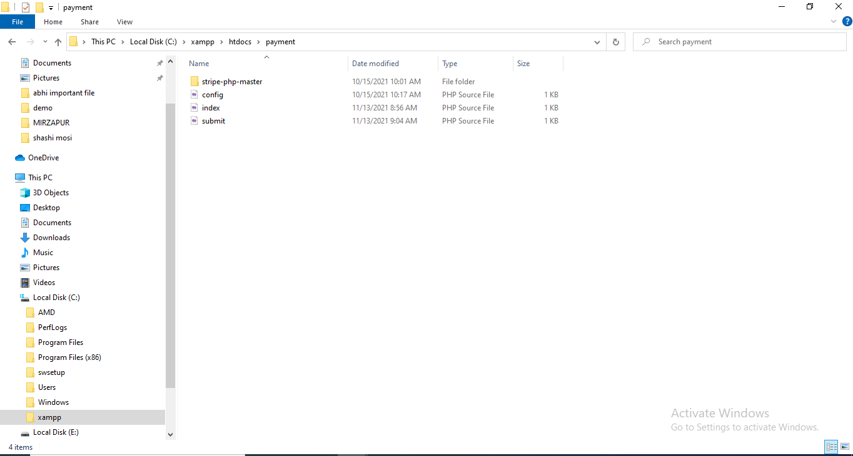

4:- go to google search stripe.com



5:- create account and login in stripe

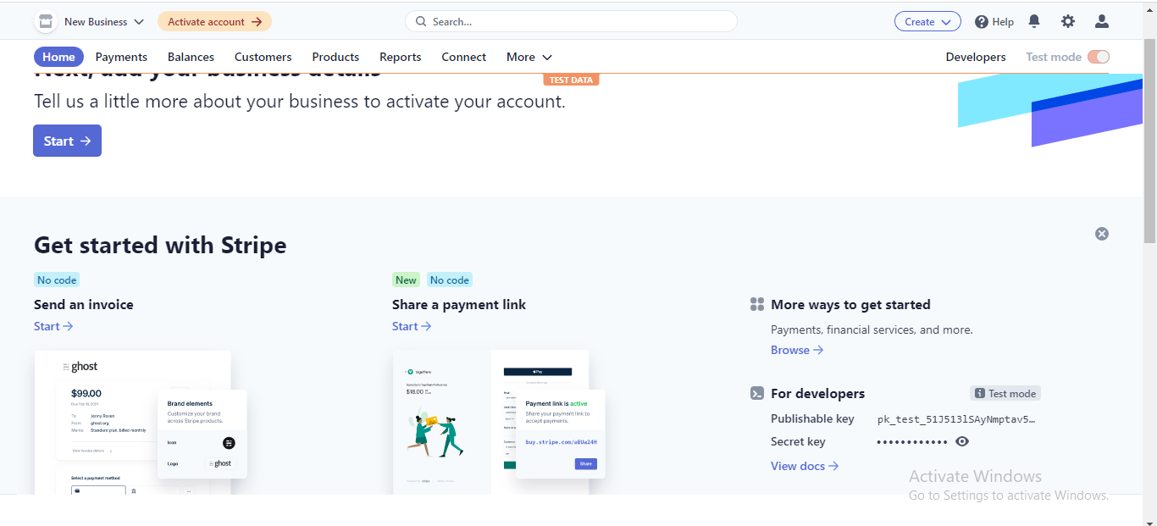

6:- Copy public key And private key and paste in config file which is created you.



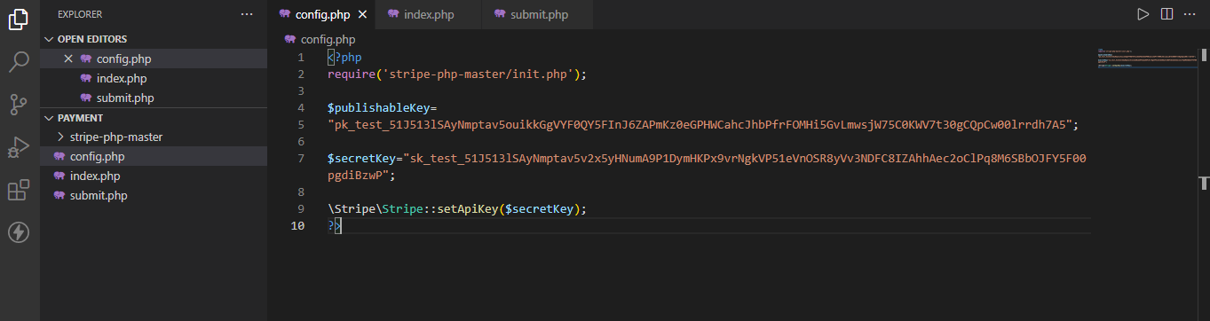

7:- create index.php

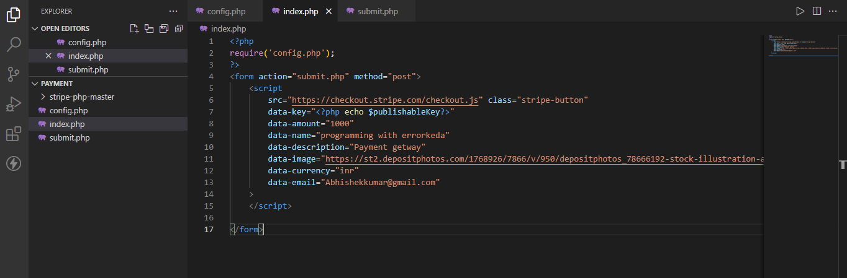

8:- create submit.php

